------= Provide =-------
Monday 3 March 2025
09:36

12th March

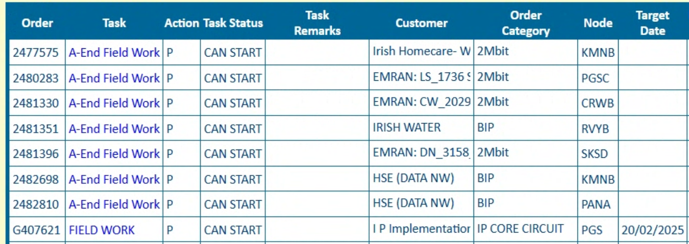

11th March

